8th - 13th January 2014

Programme for Youth from Himalayan States

[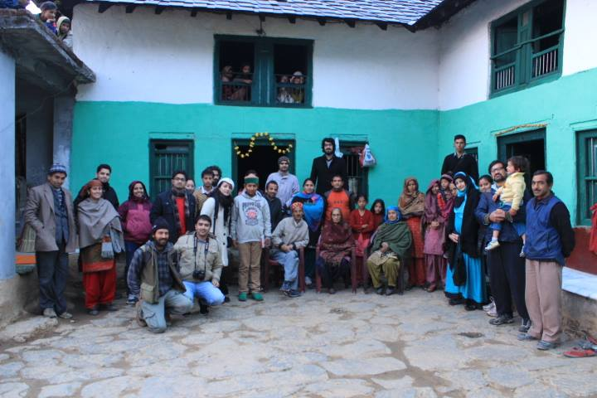](http://www.sambhaavnaa.org/wp-content/uploads/2013/11/1512685_708544099179729_592498912_n.jpg)

About the Programme

A programme titled 'Paharaur Hum: Rethinking Development in the Himalayas' targeting the youth from the three hills states of Jammu-Kashmir, Himachal Pradesh and Uttarakhand concluded at village Kandbari near Palampur on 13th January 2014. The 6 day long programme was jointly organised by Sambhaavnaa Institute of Public Policy and Politics and Himdhara Environment and Research Collective as a part of their effort to orient young participants to the challenges facing the Himalayan region and to equip them with an understanding of possible initiatives and approaches that could be used for social change in their own areas.

Participants and Faculty

The programme was attended by 19 participants from the three hill states and Delhi who were exposed to various issues related to geology, culture, forest resource management, agricultural crisis, climate change, significance of padyatra as a tool and exclusion of women and dalits. The resource persons for the programme included Sh. GirijaPande from Kumaon University (Nainital), Sh. KulbhushanUpmanyu (the noted environmentalist), Nek Ram Sharma, SukhdevVishwapremi and BimlaVishwapremi. Commenting on the programme, Manshi Asher of Himdharasaid, “The intent of the programme was to not just expose the participants to the various issues but to also to help them understand the general approaches to finding solutions to complex social problems. We are looking forward to greater participation by socially and politically motivated youth next year”

**Methodology and Process**

[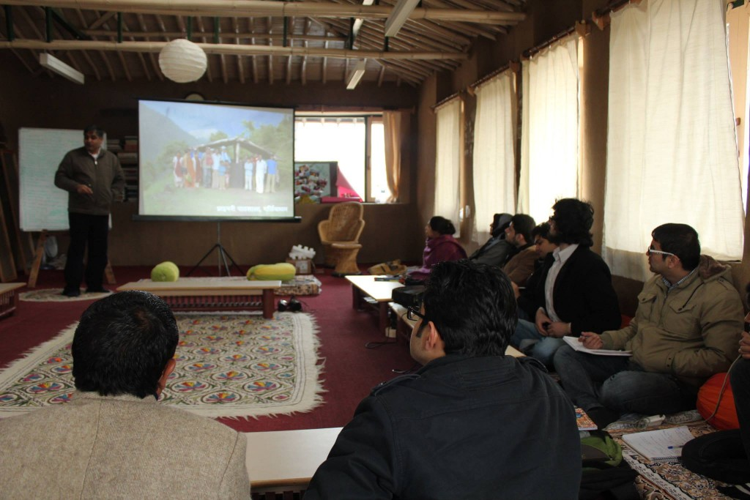](http://www.sambhaavnaa.org/wp-content/uploads/2013/11/1540418_708543565846449_1495398094_o.jpg)

Lectures, slide shows, documentaries, case studies, discussions and group exercises were used to expose the participants to the finer details of the various themes within the programme. A half day long field trip to the nearby village LoharLahri was also conducted for the participants to get a first hand feel of the community forest protection related issues in the hills. Gaddi issues were discussed with the residents of the village and their forests practices were recorded and compared  with that of sustainable practices that  in actual should be and they were suggested by the participants not to practice conventional methods but to stick to sustainable practices to earn their livelihood which they at last realize to be more exact and beneficial.

[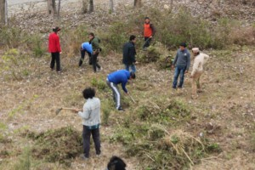](http://www.sambhaavnaa.org/wp-content/uploads/2013/11/1412681_708543712513101_1059985808_o.jpg)

**Participant Sharings**

AdityaBahl, an engineer by qualification from Barmana (Bilaspur), who quit a conventional job and opted to bring about a change in the field of education, said “The usual course in our colleges and Universities is far removed from reality and is predominantly theoretical in nature. This programme gave us an insight into the real issues on the ground and has forced me to think more seriously to work for the betterment of the communities around us.” Sumitra, who works for an NGO in Sangrah in Sirmour District, said “The sessions on Himalayan peculiarities, ecology and especially the Askot-ArakotYatra of Uttarakhand were a new learning for me. It was also interesting to know the points of view of the diverse group of participants on various issues.”

Vinayak, an engineering student from Sundernagar, remarking about the wide range of topic covered in the programme and said, “The programme content was holistic and the sessions on Himalayan ecology and the issues of Dalits and women in the hills were eye-openers for me. The friendly nature of the participants and the host organisations made the setting conducive to learning of complex issues.”

**DAY 1: 8th January 2014**

**Girija Pande:**

Evolution of The Himalayas

A History of Himalayas: Ecology, Culture and Economy; Pahari Systems of Survival

**Girija Pande, Manshi Asher:**Group Exercise on Key Words

**Day 2- 9th January 2014**

**Manshi Asher:**Reflections from previous day in game format

**Girija Pande:**

The Himalayas States of India: Setting the context: A group exercise on key issues and presentations Contemporary Development Issues in Himalayan States incl. Askot-Arakot Yatra

**Girija Pande and Kulbhushan Upmanyu:**

Himalayan Meltdown: A film on Climate Change Crisis in the Himalayas (45 minutes) + Discussion

Climate Change in the Himalayas: Impact, Magnitude, Mitigation and Policy

**Day 3 – 10th January 2014**

**Prakash Bhandari:**Reflections from previous day in game format

**Movie :Flood Ravage and the Dams of Uttarakhand (12 minutes) +**

**Kulbhusan Upmanyu:**

Development Aspirations, Policy, Impacts and Sustainability

Today’s political scenario: Impact on democracy and vision

Way forward : Rachna aur Sangharsh

**Prakash Bhandari/Rahul Saxena/Bam bam:** Presentation on sectoral Issues + why is it the way it is**.**

**Day 4- 11th January 2014**

**Rahul Saxena:**Reflections from previous day and Shramdan Film: In Search of Yarsagumba a trans-Himalayan journey (30 minutes) 

**Prakash Bhandari:**Medicinal Plant Management issues : The Chamba experience 

**Nek Ram Ji:**Karsog Experience : Agriculture and Forests

**Jeet Ram Koundal:**Self Sufficiency in Livestock Rearing: Dairy Business

**Norbu:**Sustainable tourism in Himalayas

**Day 5- 12th January 2014**

**Rahul Saxena:**Reflections from previous day

**Sukh Dev Vishwapremi:**Dalit Issues Mountain Identity and Movements for Political freedom

**Bimla Vishwapremi and Manshi:**Women’s Issues

**Manshi Asher:**Discussion on Equity Issues

**Prakash Bhandari and Sumit Mahar:**Field visit to Lohar-lahdi and talk on Gaddi issues

**Day 6- 13th January2014**

**Rahul and Manshi:** Reflections from previous day Film: Jashn-e-Azaadi Discussion on Kashmir crisis Learnings from the programme – exercise on possible strategies/ interventions

**Manshi, Rahul and Ira:** Last session : Over-all feedback on programme.

**Participants List:**

|  |  |  |
| --- | --- | --- |
| 1 | Lavrez Chaudhary | Delhi / Dehradun |
| 2 | Bhavya Sharma | 6. Vijay Nagar, Delhi |
| 3 | Sauduzzaman | Jamia Islamia/Kashmir |
| 4 | Shweta Pal | Almora |
| 5 | Isha Thakur | Manali,Dist-Kulu,Himachal Pradesh-175131 |
| 6 | Sumitra |  |
| 7 | Gowsia Saleem | Jamia Islamia/Srinagar (Kashmir) |
| 8 | Insha Imtiyaz | Jamia Islamia/Kashmir |
| 9 | Khalid Yousafzai | Jamia Islamia/Afghanistan |
| 10 | Vinayak Kaushal | Sundernagar ( Mandi ) |
| 11 | Yagyashree | Delhi |
| 12 | Kesang Thakur | Kullu |
| 13 | Hemraj Mehta | Pethoragarh |
| 14 | Aditya Bahl | Sundernagar |
| 15 | Churu Ram | Chamba |
| 16 | Sunil waliya | Kandbari |
| 17 | Susheel | Kandbari |
| 18 | Divya | Beer |
| 19 | Subhash | - |
| 20 | Ashish Arora | Beer |